**Practical no. 7**

**FS19CO042**

**Aim:** Generate complete Javadocs for any two of the above experiments

**Tool used:** Editor (Notepad/Intellij IDE), JDK and JRE

**Code:**

**File 1, exp7a.java**import java.util.Scanner;

/**

* in this class we are adding the square root of indivisual numbers;

*/

public class exp7a{

/**

* in this method we are taking the numbers as input and returning the addtion to main function;

* @param x;

* @return to main;

*/

public static int add(int ...x)

{

return x[0]*x[0]+x[1]*x[1];

}

/**

* this is the main method where the calling to add function is done and printing the result;

* @param args

*/

public static void main(String args[])

{ //creating Scanner class object and passing system.in ;

Scanner sc= new Scanner(System.in);

System.out.println("enter the first number:");

int n1=sc.nextInt();

System.out.println("enter the second number:");

int n2=sc.nextInt();

int a=exp7a.add(n1,n2);

System.out.print("the addtion of square root of indivisual is :"+a);

}

}

**File 2, exp7b.java**

import java.util.Arrays;

/**

* this is a assignment7 class for sorting the array;

*/

public class exp7b{

/**

* This is the main method where the arrays sorted and printed;

*@param args

*/

public static void main(String args[])

{

System.out.println("sorting the array.....");

System.out.println("sorted array:");

Arrays.sort(args);

for(String i:args)

{

System.out.println(i);

}

}

}

Generating docs:  
Perform following commands to generate doc:  
javadoc -d .\pathToDestination .\pathToSrc.java file.  
  
Actual commands:

javadoc -d .\javadocs\ .\exp7a.java

javadoc -d .\javadocs\ .\exp7b.java

Console output:

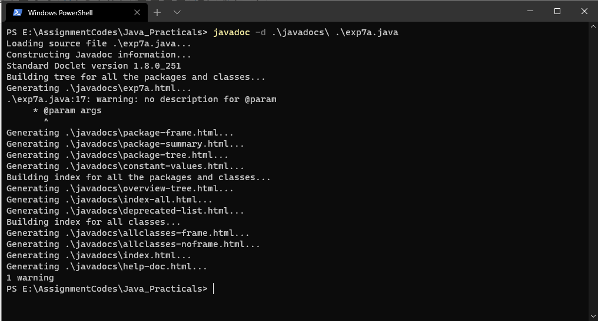

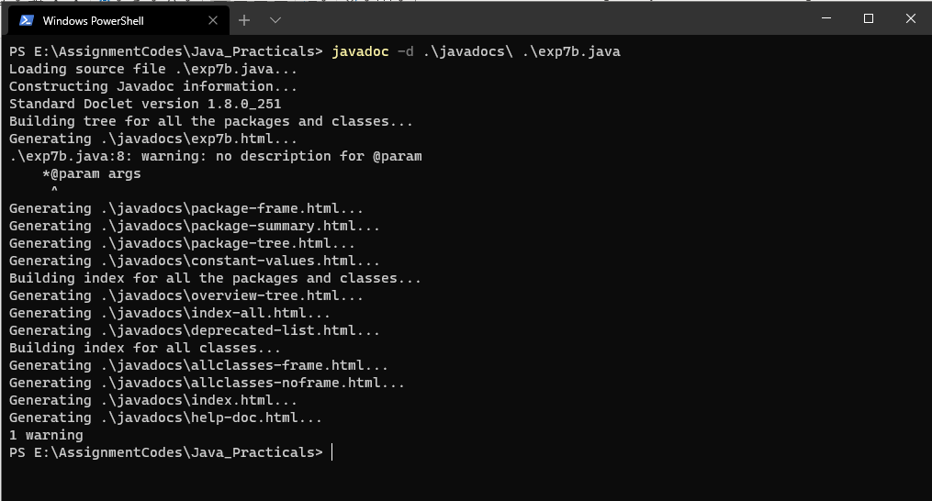

Docs Output:

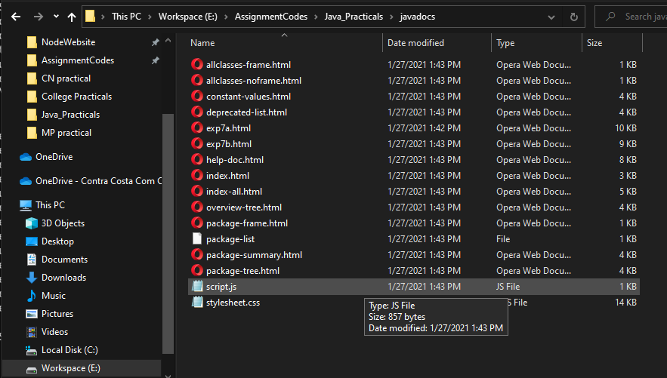

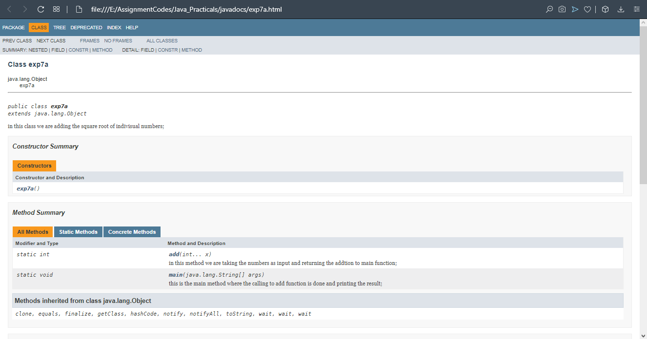

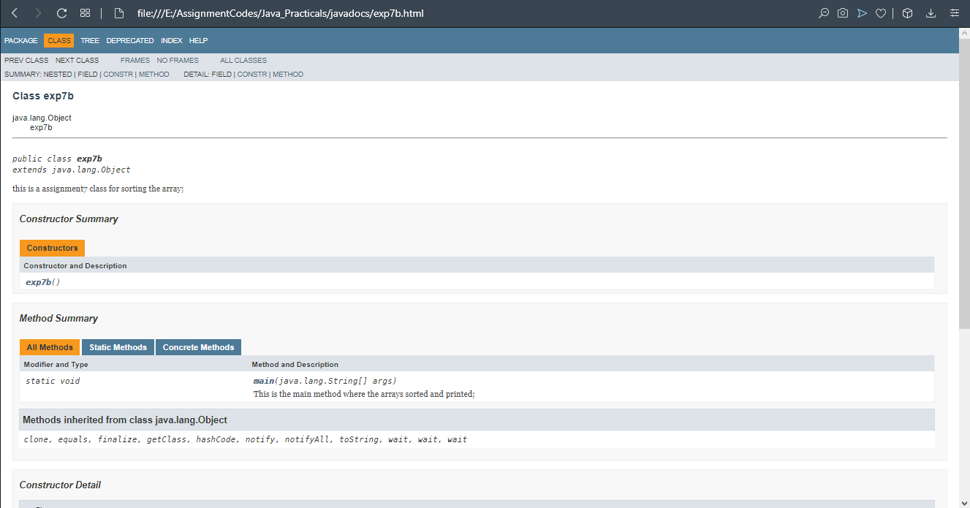

**Conclusion: Thus we understood and successfully created javadocs for our project using various techniques used for commenting and documenting java experiments.**